School Name: | Sunnyvale Primary School | School Number: | 1519
Strategic Aim: | - All learners will experience success and belonging where learning responds to their culture and identity.  - All learners will experience teaching and learning opportunities that connect the curriculum across school, home, community and culture.
Annual Aim: | To create, spread and embed educationally powerful connections and relationships.
Target: | Walk through observations and surveys will provide a pedagogical lens to student data- these walkthrough observations measured learning focused culture through student engagement in purposeful learning tasks. Our target was an 80% engagement rate across the school.
Baseline Data: | 25% of time observed students were not engaged. 39% of time observed students were engaged behaviourally, but not cognitively.  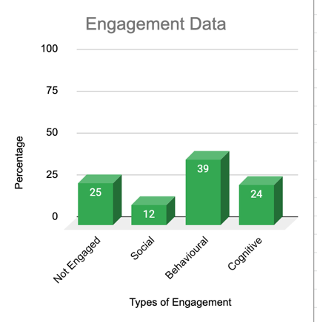

Actions  What did we do? | Outcomes  What happened? | Reasons for the variance  Why did it happen? | Evaluation  Where to next?
We worked on a co-constructed leadership inquiry. The Leadership Team carried out research and reading into student engagement and learning focused culture. We then created measurable criteria for three types of engagement: Behavioural, Social and Cognitive. Teachers worked in teams to find and share research regarding deliberate acts of teaching and theorising around these increasing engagement rates. Teams selected specific deliberate acts to implement.  Senior leaders carried out fortnightly walk-through observations. Engagement was measured and reported back to teams. This data was used as evidence to develop teacher practice through the deliberate acts of teaching.  In response to walk-through data, teams then identified subsequent deliberate acts of teaching to implement. The inquiry was iterative and responsive.  In Terms 1-2 the data was gathered during reading lessons. In Term 3 the data was gathered during writing lessons. In Term 4 the data was gathered during maths lessons. | Term 1  Whole School Data  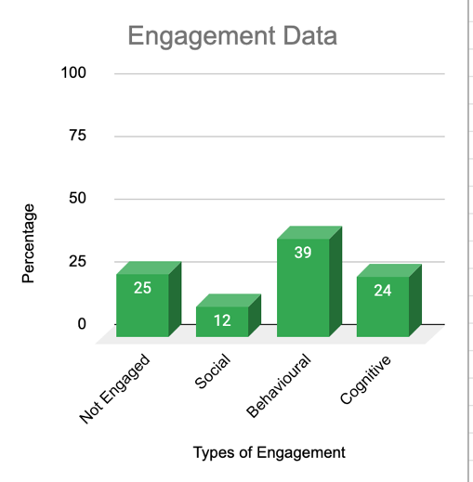  Term 2  Whole School Data  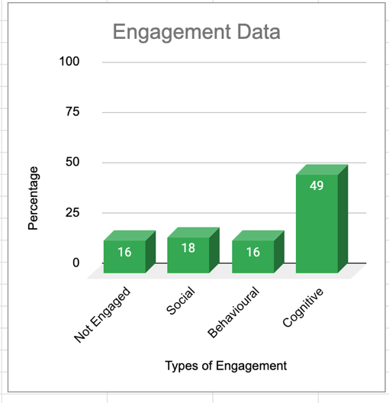  Term 3  Whole School Data  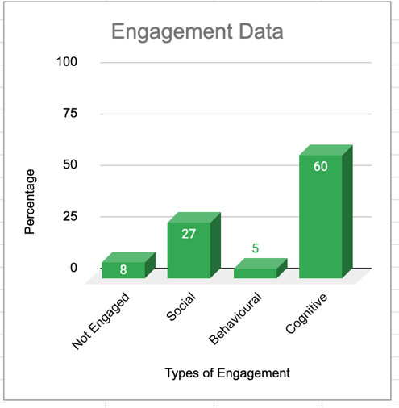  Term 4  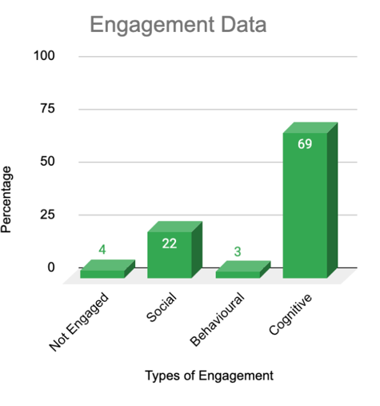 | The variance recorded indicates the shifts in pedagogical approaches. Teaching practice shifted from a behavioural focus towards a cognitive and social focus.  This happened because as a school we were developing our approach to teaching and learning through cultural relationships for responsive pedagogy. Alongside this we were redesigning our literacy curriculum, developing a whole school approach to accelerated progress and learning focused culture. The engagement inquiry was a part of those areas of development. Teachers could see the deliberate acts of teaching in literacy contexts and develop their capacity, capability and expertise to apply these.  During this time we experienced two COViD lockdowns. Teachers were able to connect the deliberate acts of teaching to the online learning platforms cohesively. Engagement measures were used in the second lockdown to explore increasing engagement through social connections online. | The variance in engagement exceeded our expectations.  By Term 3, in all classrooms, cognitive and social engagement was at 87% of total time observed. Behavioural engagement decreased 5% to and non-engagement lowered to 8%.  We had hoped to connect this data to achievement data. However, the lockdowns, particularly the second one here in Auckland, and a positive COViD case at our school resulted in a decrease in regular attendance rates, and as such progress has been impeded. We will continue into 2021, and will see the increase in achievement data after a more settled period at school.  In 2021 we will continue this inquiry- however we will further develop our understanding of engagement through specific deliberate acts of teaching and interactions in mathematics. Our achievement data in mathematics indicates this is our next area of focus.  We will be asking:  Can we apply our learning about modelling, peer talk and open-ended tasks to engagement and achievement in mathematics?  What does modelling look like in mathematics learning?  We will be engaging with the PaCT tool to support our judgements.  How can we apply our learning about whole class teaching and learning, supported by group teaching and learning, modelling books and tracking sheets from literacy to mathematics?
Planning for next year:
Strategic aim 2021-2023: All learners will make at least one year’s worth of progress every year.
Annual goal 2021: All students will have progressed 2-4 sub-levels per year.
Initiatives:
1. Establish learning support initiatives and interventions.
2. Develop shared understandings of progress indicators and deliberate acts of teaching that accelerate progress.
3. Become data literate around achievement, engagement and attendance.
Success measures:
1. Learning support programmes and interventions evident of accelerated progress.
2. Teaching practice evident of appropriate deliberate acts of acceleration.
3. 85-90 % of students achieving within or above expected levels and making 2-4 sublevels of progress per year.
4. 85-90% engagement evident through surveys.
5. 90-95% student attendance.

